**How to Use Trendy Ads to Get Quality Leads From Social Media Marketing Services**

Trendy ads are at the forefront of this revolution, offering a unique opportunity for businesses to connect with potential clients. For any [**Social Media Marketing Service**](https://syscorp.in/socialmedia-marketing), mastering the art of trendy ads can mean the difference between obscurity and remarkable success. This comprehensive guide will delve into strategies for using trendy ads to attract quality leads and enhance brand visibility.

# **Understanding The Essence Of Trendy Ads**

Trendy ads are those that resonate with the current cultural zeitgeist. They use trends, social movements, and viral material to connect emotionally with viewers. Understanding what is trending requires vigilance and adaptability, as trends can change at lightning speed. Successful brands often employ trendwatching strategies to stay informed, using social listening tools and market research to identify what captivates their target demographic.

Relevance is the core of any trendy commercial. It is critical to fit the ad's messaging with the values and interests of the target demographic.This relevance cultivates trust and encourages engagement, transforming casual viewers into interested leads.

## **Crafting Visually Striking Ads**

Visual elements are the cornerstone of any advertisement. In a social media environment cluttered with content, compelling visuals can captivate attention. When designing trendy ads, it is crucial to incorporate innovative [**website design**](https://syscorp.in/web-development) principles that create a seamless user experience.

1. **High-Quality Imagery**: Utilize striking images that evoke emotions and communicate the essence of the brand. High-resolution photos or illustrations that align with the brand's aesthetic can significantly enhance ad appeal.
2. **Dynamic Video Content**: Video ads often outperform static images in terms of engagement.A well-produced video can show off items, explain services, or narrate brand tales, making the material more engaging and immersive.
3. **Color Psychology**: Color plays a critical role in consumer perception. Understanding how different colors elicit distinct emotions can aid in creating advertising that resonates with the audience. For example, blue can convey trust, whereas red can convey urgency.
4. **Typography**: Typography should complement the overall design and enhance readability. Choosing the right fonts can have a big impact on how the advertisement is received.

## **Developing Engaging Copy**

Once the pictures get people's attention, the ad writing has to keep them interested. Crafting succinct and persuasive messaging is paramount for converting interest into action. Here are some strategies to consider:

1. **Clear Value Proposition**: Communicate the unique selling points (USPs) of the **Social Media Marketing Service** in a way that addresses the audience's pain points.
2. **Storytelling**: Humans are naturally drawn to stories. Brands may provoke emotions and leave a lasting impact by including storylines into their commercials. Consider sharing success stories or reviews from happy customers that show how your services have helped them.
3. **Call to Action (CTA):** A great CTA is critical for guiding potential leads to the next step. Whether it’s “Sign Up Now,” “Learn More,” or “Get a Free Consultation,” the CTA should be clear, compelling, and relevant to the ad's message.

# **Incorporating Interactive Elements**

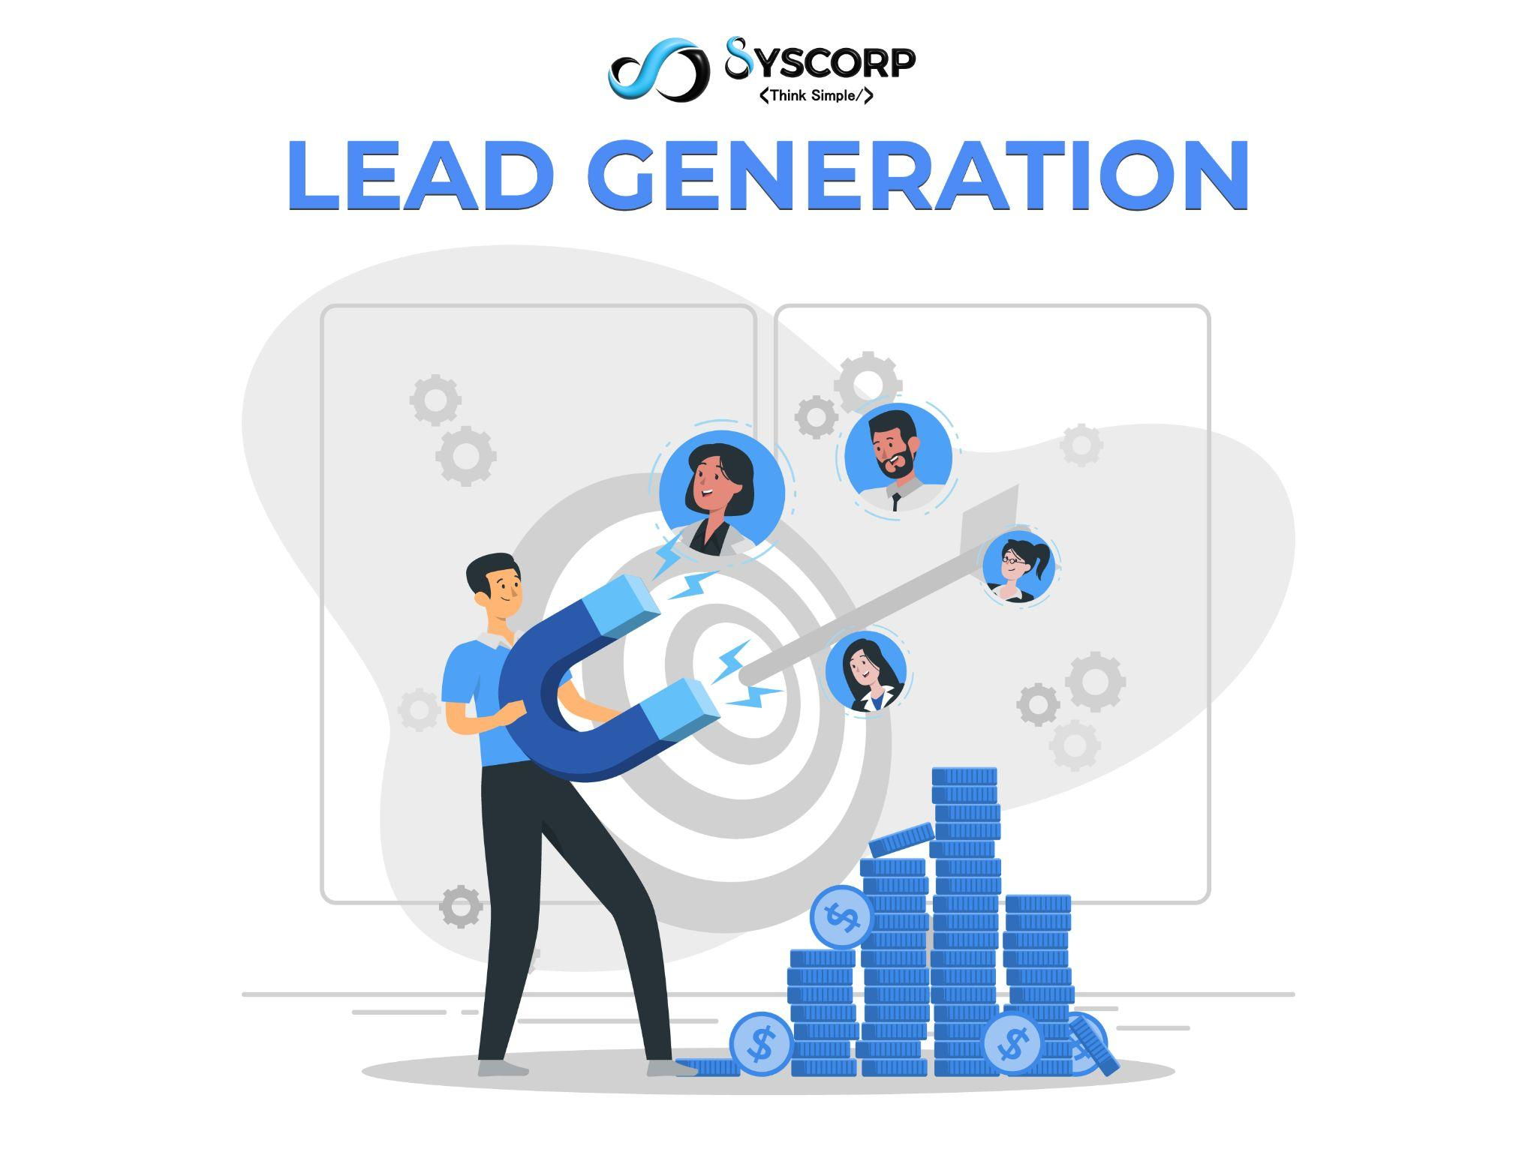

Interactivity can considerably improve engagement in the domain of trendy advertisements. Interactive advertising encourages people to participate rather than just consume material. This encounter promotes a greater connection to the brand.

1. **Quizzes and Polls**: Incorporating quizzes that gauge users’ social media prowess can provide valuable insights while keeping them engaged.For example, a quiz evaluating social media methods might emphasize the importance of your **Social Media Marketing Service**.
2. **Augmented Reality (AR)**: People can engage with products or services in new ways with the help of augmented reality (AR) experiences. For example, a virtual try-on function for products can greatly improve user experience and conversions.
3. **Contests and Giveaways**: Encouraging participation through contests or giveaways can generate excitement and extend reach. Ads with incentives have a higher chance of being shared by users, increasing brand awareness and drawing in quality leads.

# **Leveraging Influencer Partnerships**

Influencer marketing has surged in popularity, presenting a powerful avenue for trendy ads. Collaborating with influencers who support your brand might deliver significant results.Here's how to take advantage of influencer partnership opportunities:

1. **Choosing the Right Influencer**: Selecting influencers whose audience mirrors your target demographic is crucial. Their ideals, style, and level of engagement should be consistent with your company's ethos.
2. **Authenticity Matters**: Audiences value authenticity.Influencers are more likely to offer enticing endorsements that resonate with their audience if they genuinely believe in the good or service.
3. **Co-Creating Content:** Engaging influencers in the content creation process might result in more authentic and relatable advertisements. Their insights could help increase creativity and create ideas that resonate more deeply with the audience.

# **Analyzing And Adapting Strategies**

Continuous analysis is vital for refining advertising strategies. Trends change quickly, and the digital scene is dynamic. By using data analytics tools to track ad performance, marketers can make well-informed choices.

**A/B testing:** You may find out which kinds of ads, messages, and graphics your target audience responds to best by testing out different formats. A/B testing can reveal the factors that lead to conversions and engagement.

**Tracking Engagement Measures:** Insights on the effectiveness of advertisements can be gained from metrics such as click-through rates, conversions, and social shares.These stats assist us analyze audience behavior and preferences.

1. **Feedback Loops:** Ad campaigns advantages and disadvantages can be identified by paying attention to audience input. Engaging with users through comments and direct messages provides a wealth of information that can inform future strategies.

## **Staying Ahead Of Trends**

A dedication to continuous research and development is necessary to stay ahead of trends. Regularly engaging with industry news, participating in webinars, and attending conferences can provide fresh insights and innovative ideas.

1. **Tools for Trendwatching:** Make use of these resources to monitor new trends and changes in consumer behavior. These observations can support the continued relevance and efficacy of advertising campaigns.
2. **Networking:** Developing relationships with other industry professionals can provide access to useful resources and information. Discussions about current trends can inspire and drive innovation.

# **Conclusion**

Social media platforms offer vast potential for targeted advertising, allowing businesses to fine-tune their campaigns based on demographics, interests, and behavior patterns. Syscorp Technology, with its expertise in [social media marketing services](https://syscorp.in/socialmedia-marketing), excels at utilizing these cutting-edge trends to optimize ad performance, ensuring that businesses not only reach a broader audience but also convert them into high-quality leads efficiently. With the right strategy and execution, trendy ads can significantly boost a company's growth and lead generation efforts.  
  
Visit our website for more information: <https://www.syscorp.in/>